The Proportion of Chinese College Student Driver Licensing and Underlying Reasons
张芝源 2024010701 group 2

Results

Reaffirmation of experimental purposes and RQs
The main objective of our research was to investigate the percentage of Chinese university students who had obtained a driver's license and compare it with foreign past domestic data. With data in hand, the two RQs are going to be addressed. One was to investigate the key factors that affected college students' initiative to obtain a driver's license. The other was to delve into the underlying reasons that influenced Chinese college students' motivations to obtain a driver's license.
Approach
The survey asked participants to complete a questionnaire that reflected their status of obtaining a driver's license and investigated the reasons behind it. As mentioned in Method section, the number of valid applicants in the questionnaire was 317, of which 227 were males (71.67%) and 90 were females (28.39%). All of them were college students. Among them, undergraduates accounted for the vast majority, with a total of 311(98.11%).

Results of the online questionnaire

Figure 1 The percentage of participants who had driver licensing

Note: Among all subjects, the number of people with a driving license was 138,179, in male subjects, the data was 102 and 125, respectively, and in female subjects, this data became 36 and 54. Table 1 shows their respective proportion. For those who were taking their driver's license at this moment, we classified them as the first category (have obtained).

As can be seen from Fig. 1, 43.53% of people had obtained a driver's license, lower than the 56.47% who had not. This remained true regardless of gender. However, 44.93% of male participants had obtained a driver's license, slightly higher than the 40% of female participants.

Table 1
The change of the proportion of college students with driver's license in China and USA
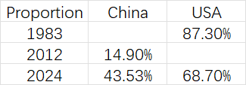

Note: USA’s statistics came from Federal Highway Administration. The statistics in 2012 came from “Dataway” ——a Chinese statistics company. Data for China in 2024 were based on this survey.

Although the percentage of college students in the United States who have a driving license was always higher than that in China, over the past 41 years, the percentage in the USA decreased by 18.6% (see Table 1). However, compared to 12 years ago, the percentage of Chinese university students who had obtained a driving license has increased significantly, from 14.90% to 43.53%.

Table 2 Percents of the reasons for getting a driving license.

Note: It's important to note that only those who already had a driving license participated in this question. The number of valid responses to this question was 317.

Table 2 presents the reasons why participants obtained a driving license, along with the corresponding numbers and percentages for each reason.
It can be found from Table 2 that the majority of participants (67.39%) reported obtaining a driving license because they wanted to do so on their own initiative. A smaller proportion of participants (16.67%) indicated that seeing others learn to drive influenced their decision to obtain a license. Finally, some participants (15.94%) stated that their parents required them to get a driving license.

Table 3 Proportion of reasons for wanting to obtain a driver's license

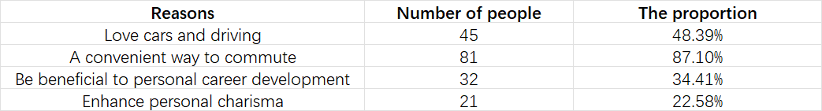
Note: Only those who selected the first option (I wanted to get it on my own initiative) in the previous question participated in this question, and this is a multiple-choice question. The number of valid responses for this question was 93.

Table 3 provides insights into the motivations behind individuals' enthusiasm for obtaining and utilizing a driving license, based on responses from 138 participants. Among those who had obtained a driving license, the most common reason for enhancing their enthusiasm was that it provided a convenient way to commute, with 81 participants (87.10%) selecting this option. The second most popular reason was a love for cars and driving, chosen by 45 people (48.39%). Other benefits included the enhance of personal charisma (22.58%), as well as being beneficial to personal career development (34.41%).

Table 4 Proportion of the reasons for not getting a driving license

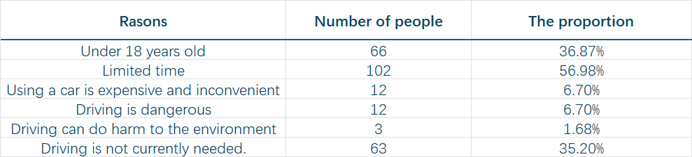
Note: Only those who have not obtained a driving license participated in this question, and this is a multiple-choice question. The number of valid responses for this question was 179.

The results in Table 4 suggest that the top three reasons why people had not obtained a driving license were “Limited time” (56.98%), “Underage” (36.87%) and “Driving is not currently needed” (35.20%). Only a small percentage of people thought driving to be expensive, dangerous or harmful, accounting for 6.70%, 6.70% and 12.68%, respectively.
This showed that people were not inherently negative about driving itself, instead, their attitudes were more influenced by objective factors such as age, time, and practicality.

Table 5
Proportion of why people think they do not need a driving license at present
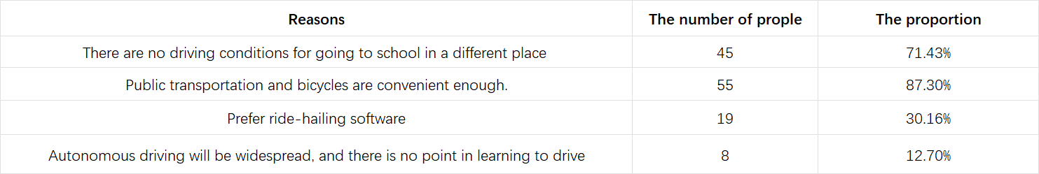
Note: Only those who selected the last option (Driving is not currently needed) in the previous question participated in this question, and this is a multiple-choice question. The number of valid responses for this question was 63.

Table 5 outlined several reasons why individuals felt they did not require a driving license at present, accompanied by the number of people endorsing each rationale and its corresponding percentage. Notably, the largest group believed that public transportation and bicycles were convenient enough, accounting for 87.30%. Another substantial portion (71.43%) of people noted the lack of driving conditions when attending school away from home. Meanwhile, 30.16% of them preferred using ride-hailing apps over owning a car. Lastly, a smaller segment of 12.70% anticipated the widespread adoption of autonomous driving technology, which would render traditional driving skills obsolete in the future.
Results of interview
To consider additional reasons why people did or did not want to obtain a driving license, researchers randomly selected 12 participants to talk about their motivation for wanting to get a driving license or not wanting to get one, as well as whether or not they would use cars as the primary means of transportation after obtaining a license. Researchers conducted online interviews to minimize nervousness and other emotions that might arise in face-to-face interviews, ensuring that the interviews were as realistic and objective as possible. Here we list the factors that they mentioned but were not covered in the questionnaire.
Among the interviewees who had already obtained a driver's license, three participants said that the reason why they took the driving license test was that they had time at that moment, and would be in need of driving sooner or later. Another person mentioned that he wanted to get a driving license for the convenience of life during his future study abroad. Other factors included the intention to be able to travel by car. Most of them regard public transportation as their primary means of commuting in the future.
Among the interviewees who had not obtained a driving license, one female participant believed that girls did not need to get a driver's license, due to traditional mindsets. Another interesting viewpoint was expressed by a male participant, who stated that he would not choose to drive even if he successfully obtained a license.

Discussion

The important findings of the research
The data from Fig.1 suggest that slightly more than fifty percent of students have not obtained a driving license, and the enthusiasm of male students towards obtaining a driver's license is slightly greater than that of female students, but it is not a distinct difference. There is no significant correlation between gender and the desire to drive. This finding challenges our traditional perception that boys are often more enthusiastic about driving than girls. Our finding just proves that people's ideas are constantly changing with the changing times.
The following paragraph presents the most important findings in our research. The percentage of students who have obtained a driving license is 43.53% (see Table 1), and the key factor that enhances their desire to obtain a driving license is the view that driving can be a convenient way to commute (see Table 2), while the most influential factor that discourages people from getting a driver's license is that public transportation and bicycles are convenient enough (see Table 5). These findings successfully answer RQ1.
As for RQ2, the results of the interview provide an answer. Underlying reasons that influence people’s desire to learn how to drive include whether they are available at present and whether learning to drive will benefit their future studies and careers. Another factor that influences students’ initiative is the voices of those around them and in society.
From Table 2, it can be seen that most people who choose to get a driver's license do so because they actively want to. Although some people obtain it due to parental pressure or the herd mentality, the proportion is relatively low (32.61%). Table 3 shows that people pay more attention to the functionality of driving when choosing to take a driver's license test. Table 4 further supports this, as 35.20% of students believe they have not obtained a driver's license because they do not need it at the moment.

Comparison of the results with other published works

Table 1 presents a smaller percentage of Chinese college students with a driving license compared to U.S. college students. We believe this is closely related to the different national conditions of China and the United States. One factor that correlates with our findings is that China's public transportation network is more developed than that of the United States (Han,2015) This is supported by our research, where 97.30% of those who do not have a driver's license believe that transportation is convenient enough (see Table 5). However, further research is needed to determine whether the two are causally related. Another factor is that the per capita disposable income in the United States is higher than in China (Data are from the National Bureau of Statistics and the U.S. Census Bureau). Similarly, whether there is a causal relationship needs to be studied in the future, which highlights the significance of our research.
The fact that the proportion in the U.S. has been decreasing over time also corroborates the conclusion that “In recent years, the proportion of young adults who own and drive has been declining in many developed countries."(Melia et al., 2018).
As stated by Shults and Williams (2013), "It finds that between 1996 and 2010 the percentage of U.S. students with a driver's license decreased from 83% to 73%." (p. ). However, contrary to this trend, the proportion of Chinese college students obtaining a driver's license shows a positive correlation with the passing years. This discrepancy suggests that our research improves upon previous surveys. The progress of people’s ideological concepts, in line with the ongoing reform and opening-up, is likely correlated with this trend. Our research also fills the gaps in previous studies, which mainly focus on trends of the Western countries.
As can be seen from Table 4, unlike the results found by Delbosc and Currie (2013), who argued that "insurance costs and license costs" are important barriers to obtaining a driver's license, Chinese university students are less concerned about the financial burden of owning a car, as only 6.7% of them believe that using a car is expensive. And why?
Among the reasons for the reluctance to obtain a driver's license, our findings show a high degree of similarity with previous results. In our research, the leading cause of reluctance to get a driver's license is lack of time. In the research of Schoettle & Sivak, (2014), the top 1 reason is “too busy or not enough time to get a driver’s license”. This shows a similarity between Chinese students and foreign students when it comes to the unwillingness to obtain a driver's license.
Discussion不宜使用太多直接引用。需要作者对以往研究的内容进行再解读，才能和自己的研究联系起来。

Strengths and limitations of the study 过去时
The strengths of this study are as follows: Firstly, the combination of online questionnaire and interviews allowed for wider dissemination of the questionnaire and made the sampling as random as possible. Secondly, we searched extensively for foreign papers to ensure the authenticity of DDL trends and to make it convenient to compare with the trend in China.
However, some limitations exist in our study. First and foremost, the generalizability of the results is limited by the small sample size. In addition, people who are interested in cars may be more likely to fill out the questionnaire, which impacts the reliability of the data. Finally, we did not investigate the correlation between the obtainment of a driver's license and household income, which requires follow-up research by others.

Conclusion and possible implications of the study

The results have answered our research questions well and fulfilled the research purposes successfully. In conclusion, 43.53% of college students in China have a driver's license, which is higher than in the past but not as high as that in the United States. This motivation shows limited correlation with gender. The factors that influence people's motivation are mentioned at the beginning of the discussion section.
This study provides valuable insights into the current trends regarding Chinese university students’ acquisition of a driver’s license. It highlights the changing motivations behind students’ decisions, including the influence of convenience, personal development, and societal factors. The significant increase in the percentage of students with a driver’s license in the past decade suggests a shift in attitudes towards driving, likely influenced by China’s growing economic development and urbanization. Moreover, the study’s findings that public transportation and new technologies such as autonomous driving are shaping students’ perspectives on driving, emphasize the importance of considering these evolving factors in future transportation policies and educational programs. The research also contributes to a broader understanding of how global trends, such as the decline in car ownership in developed countries, are manifesting in the context of Chinese youth. This provides a foundation for further studies examining the impact of socio-economic factors on mobility choices and the future of driving in China.
This study helps people better understand the proportion of contemporary Chinese college student with a driver's license. Its key findings could delve into the underlying reasons behind the statistics, making our study socially significant.

Future research questions based on the findings

Given the limitations of our study, here are some recommendations for future research. Future research should take into account the correlation between willingness to obtain a driver's license and household income, to further validate the correctness of the results found by Vaca et al. (2024), who suggest that “youth with low income backgrounds are more likely to delay licensure compared to high income youth." Another avenue for future research is to consider the age of participants as a variable to explore the main factors influencing the decision to obtain a driver's license at different ages.
保持用过去时报告和讨论研究结果
内容较丰富
Results建议按研究问题分小节，而非按照问卷题目流水账式描述。每一个段落应该有总起句立刻告诉读者本段的内容是关于什么。
Discussion目前整体逻辑不够清晰，建议按照研究问题重新分小节，和results对应起来。和美国数据比与和以往研究结论比显得有点穿插，不是很明确。

R中不要出现其他的研究结果，放到D中
D需要与R的部分对应
注意语言细节
9+8.5

